**PRACTICAL – 4(3)**

**Aim:** **Create a class named 'Rectangle' with two data members 'length' and 'breadth' and two methods to print the area and perimeter of the rectangle respectively. Its constructor having parameters for length and breadth is used to initialize length and breadth of the rectangle. Let class 'Square' inherit the 'Rectangle' class with its constructor having a parameter for its side (suppose s) calling the constructor of its parent class as 'super(s,s)'. Print the area and perimeter of a rectangle and a square. Also use array of objects.**

**SOURCE CODE:**

public class Practical_4_3 {

    public static *void* main(String[] *args*) {

        Square[] obj = { new Square(), new Square(2.0f), new Square(5.0f) };

*int* i = 0;

        for (i = 0; i < 3; i++) {

            System.out.println("object" + (i + 1) + ":\n");

            obj[i].display();

        }

    }

}

class Rectangle {

*float* lenght, breadth;

    public Rectangle() {

    }

    public Rectangle(*float* *a*, *float* *b*) {

        lenght = *a*;

        breadth = *b*;

    }

}

class Square extends Rectangle {

*float* side;

    public Square() {

        super();

    }

    public Square(*float* *a*) {

        super(5, 5);

        side = 5;

    }

    public *void* display() {

        System.out.println("Area of rectangle:" + (lenght * breadth));

        System.out.println("Perimeter of Rectangle:" + (2 * (lenght + breadth)));

        System.out.println("Area of Square:" + (side * side));

        System.out.println("Area of square:" + (4 * side));

    }

}

**OUTPUT:**

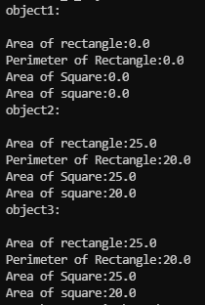

**CONCLUSION:** In this program I learnt about invoking constructor of parent class in the constructor of child class. This is possible with the help of super keyword. It can also be used to access data members and member functions of parent class.